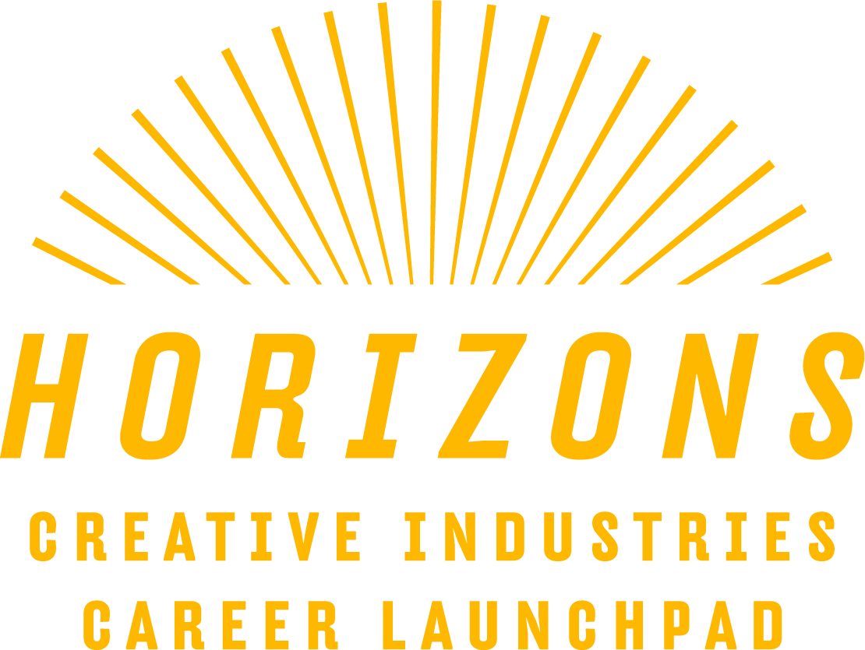
Mentor
Expression of Interest
Horizons Creative Industries Career Launchpad

Become a Mentor for this exciting Regional NSW Youth Project!
We’re looking for practicing artists based in regional NSW who have a passion for supporting the next generation of creatives.
EoI closes midnight Wednesday 21 February 2024.

ABOUT THE PROJECT
Horizons is a creative industry mentoring and career development program for NSW regional youth. The project will run over 18 months and will support a total of 75 young people from across NSW.
Horizons is a state-wide regional project that provides direct intensive support to young people wanting to pursue a career in the creative industries. Our aim is to provide participants with new pathways to explore work and study opportunities in the creative industries.
Participants will be connected with an experienced mentor from their chosen field who is based in regional NSW. Each mentoring relationship will address the needs and interests of each individual and enable participants to connect into a network of peers to build strong state-wide networks early in their careers.
There are plans to share the experiences of the participants and mentors at the culmination of the project, highlighting the range of creative practice and industries represented. Our aim is to draw attention to the opportunities open to regional young people in the dynamic and evolving creative industries. The form of this ‘showcase’ will be developed in partnership with the participants.
ABOUT THE REGIONAL ARTS NETWORK
The Regional Arts Network (RAN) consists of 15 Regional Arts Development Organisations (RADO’s) supporting and advocating for arts development and engagement across Regional NSW.
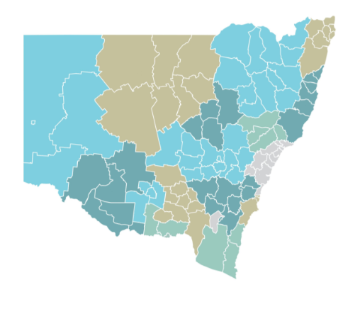
You can find out more about the network HERE

WHAT IS A MENTOR?
A mentor is a person with experience, knowledge, and connections.
Many people attribute part of their professional growth to the guidance of a patient mentor who challenged them to think differently and open their eyes and mind to different perspectives.
Mentors can answer questions about their field and challenge their mentees to think critically about their career paths. Usually established as more senior members of an industry, mentors are well-situated to help participants/mentees consider their long-term development.

WHO YOU WILL BE WORKING WITH & WHAT IS YOUR ROLE?
You will be connected with 5 – 6 young people, aged between 16 – 25, who have an interest in a similar field of creative practice that your career has focused on.
By the end of the 8-month mentoring program we want the participants to have a deeper understanding of the opportunities for a creative career, be inspired to continue to develop their practice and have increased confidence in being a regional practitioner.

TIME COMMITMENT
We estimate your total time commitment to be approximately 60 hours across the life of the contract. The Mentorship sessions are scheduled to begin in early April 2024.
This includes:
- Online training program, facilitated by Creative + Business, (March 2024)
- Monthly online group mentoring sessions with your Horizons cohort (5 – 6 participants),
- Monthly individual mentoring sessions with your Horizons cohort.

REQUIREMENTS
- If your mentoring group includes any young people under 18 you will be required to hold a valid Working With Children Check.
- As all mentoring will be conducted remotely and online you will need a stable and reliable internet connection plus access to the technology (hardware and software) to engage through an online platform. (You don’t need to be an expert at using online meeting platforms as the project team can support you to become familiar with these.)

WHAT IT’S NOT
The role of Mentor can regularly be confused with that of a Coach. We thought it useful to outline what this role is NOT and functions you are not expected to undertake;
- You are not a coach,
- You do not need to tell the mentees exactly how to do things,
- You are not expected to help resolve transactional, short-term problems,
- You are not a counsellor or therapist.
TIMELINE
The online mandatory training will be scheduled for March 2024
The mentoring program will take place April – October 2024 (= 7 months)

FEE
Each mentor will receive a $4490 fee + superannuation.
As all mentoring will be conducted remotely there is no allocation for travel.

THE SUPPORT WE PROVIDE YOU
All Mentors will be required to participate in an online training program presented by Creative + Business. This program is designed to develop a shared understanding of the role of the mentor, discuss best practice, challenges, and possible solutions. This training is provided at no cost to the Mentors.
The project team will be available to support you across the life of the project. Your main point of contact will be Lead Mentor Narelle Vogel and Project Manager Fabian Pertzel with additional support from, First Nations Youth Coordinator Emma Johnston and Communications Manager Max Wilson.

HOW TO APPLY
We’ve created a Google Form for you to submit your expression of interest.
It asks you for;
- Contact details,
- CV, no more than two pages, highlighting your creative and professional practice that makes you perfect as a mentor,
- A statement on why you would like to be a mentor and what skills, experience and insight you bring, no more than 1500 characters,
- Your thoughts on the future of the regional creative industries and the challenges faced by young people starting their career, no more than 1000 characters.
You can find the form HERE
Please submit your EoI no later than midnight Wednesday 21 February.
We will be unable to extend this deadline as the selection of successful candidates will be taking place the following day. Please provide all relevant information so we can develop an understanding of your skills, experience, and suitability for the Mentor role.

CONTACT DETAILS FOR PROJECT TEAM
If you require any additional information or have questions you can call Project Lead Mentor Narelle Vogel on 0458 716 283 or Project Manager Fabian Pertzel on 0427 532 044

Horizons – Creative Industries Career Launchpad is funded by through the Regional Youth Incentive Program of the Office of Regional Youth and the NSW Regional Arts Network.

